The R efficiency project is a work in progress. **DO NOT USE TO ANALYZE DATA UNTIL COMPLETED**

**Quick Instructions:**

1. Move the efficiency project files in with the other R scripts (They will be moved there upon completion of the project)
2. Open the Analysis AutoSetup.R program

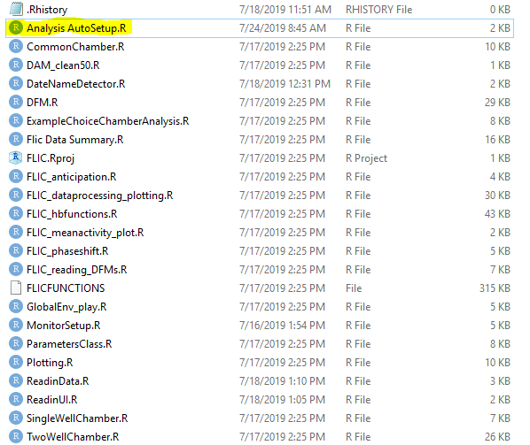

1. Click “Source” on the top right to run the program. Do not click run.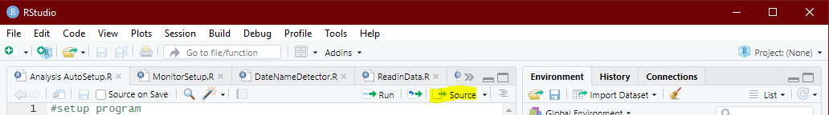
2. Follow instructions given by the program, it will generate the bin files and text files required for ClockLab up until step 9 at FLIC Raw Data Processing and Plotting. Continue and analysis from there.

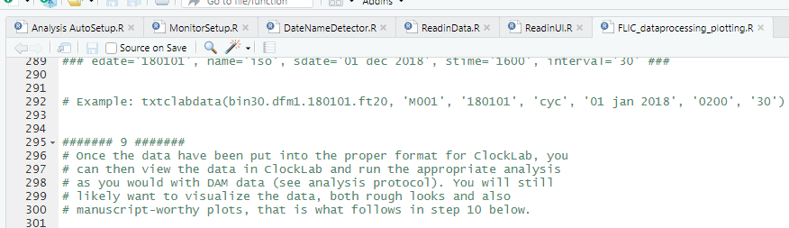

**Step by step instructions:**

NOTE: It is recommended to avoid starting this process until you are ready to read in the data (which takes hours and renders the computer unusable). This is not necessary but allows you to do the entire process smoothly.

1. Download the **R folder** from the feeding project in OneDrive. This only needs to be done once per person.

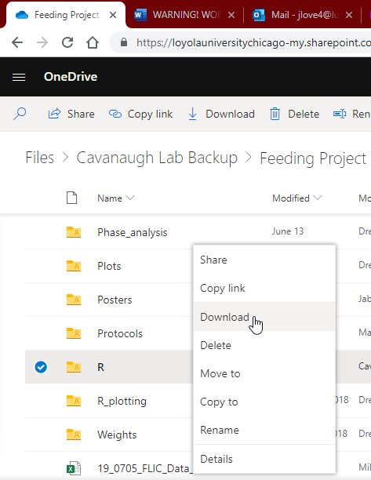

1. Open the folder you downloaded and double click on “**Analysis AutoSetup.**” This will open RStudio



1. Click “**Source**” in the top right of the Analysis AutoSetup window. This will run the AutoSetup program. DO NOT CLICK RUN.



1. The Console at the bottom will prompt for the directory of your scripts (A). **Open the R folder** you downloaded and **click to the right of ‘R**’ (B). This will bring up the address of the file. It is okay if this is different from the picture. **Copy the directory** (C) and **paste it to the console** (D). Press enter.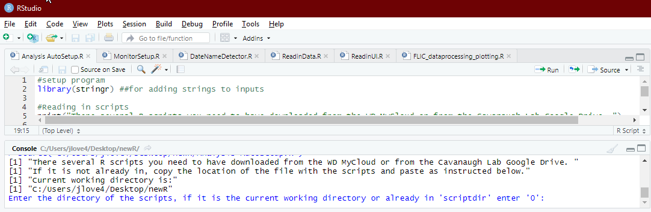A

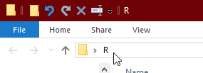(B) 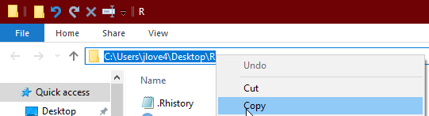(C)

(D) *sample file directory*

1. It will now prompt for the working directory. **This is the directory of the data**. **Open the folder that contains your data** and **copy over its address** the same way you did with the R folder. Press enter again.
2. The program will ask if you would like to begin monitor setup. Type “1” then click enter. A bunch of text will appear, this is okay.

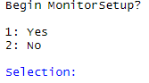

1. The program will prompt the monitor type. Type “1” if the experiment used sables or “2” if it used v2.1’s. If you are unsure, this information is available in the OneNote under the tab for your particular experiment. This menu style will be used for the rest of this program.

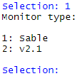

1. The program will now prompt the number of wells, 6 or 12. This is **virtually always 12**. **Type 2 for 12 wells.**
2. The program will ask how you want to run the setup. **Select “default”** unless you are running an abnormal experiment and need to change any of the settings listed in the footnotes.[1]
3. The program will prompt to run DateNameDetector. Select yes.
4. The program will attempt to guess the **start date** (format YYMMDD), **experement ID** (A short expiriment discription like pdfCycDN), and **three letter ID** (A three letter code needed for clocklab. The value is not especially important.) **If the value(s) prompted is correct select yes, otherwise select no and put in the correct value.**
5. The program will prompt to read in data. **This process is extremely resource intensive! Only run it when nothing is going to be done on the computer for hours, preferably overnight.** If you are prepared to run it select yes and skip to step 14. Otherwise select no, stop here and proceed to step 13 when you are ready to run.
6. (**IF NO WAS SELECTED IN STEP 12**) So long as R was kept open and nothing else was done on it on your account you can resume the program by **opening “ReadinUI”** in the **R folder** and running it. Proceed to step 14
7. The program will prompt for a **Start DFM**. This is the **lowest DFM number in your data set**. Enter the DFM number and click enter.
8. The program will prompt for an **END DFM**. This is the **highest DFM number in your data set**. Enter the DFM number and click enter.

NOTE: previously you could only read in 5 DFM’s at a time due to memory constraints, this is no longer the case. The program will automatically split the save files into chunks of 5.

1. If you are reading in more than 5 DFM’s the program will warn you that it will split up the save file. Select **yes.**
2. The program will prompt for bin length. **Enter the desired bin length.** (The FLIC experiments use a bin length of 30)
3. The program will pause for a second and then start outputting numbers. This means the program was successful, and it is now safe to leave the program to run on its own. In the file with your data it will generate the .txt files clocklab uses as well as save files with all the bin data for further analysis.
4. Proceed analysis starting at step #9 of the original protocol in FLIC_processingandploting.

***IF AN ERROR OCCURS:*** If an error occurs that causes the program to break before completion, type “rm(list = ls())” and press enter. Start over at step 3. If the same error continues to occur defer to the old protocol in FLIC_processingandploting.

***IF A MISTAKE OCCURS:*** If you make a mistake, press *esc* to quit the program. Type “rm(list = ls())” and press enter. Start over at step 3.

1. Signal Threshold, Feeding Threshold Value, Feeding Interval Minimum, Tasting Threshold Interval Min, Tasting Threshold Interval Max, Feeding Minevents, Adaptive Threshold